**ASSIGNMENT-1**

Q1. What is AWS? Explain in detail with block diagram.

* AWS (Amazon Web Services) is a comprehensive, evolving [cloud computing](https://www.techtarget.com/searchcloudcomputing/definition/cloud-computing) platform provided by Amazon that includes a mixture of infrastructure as a service ([IaaS](https://www.techtarget.com/searchcloudcomputing/definition/Infrastructure-as-a-Service-IaaS)), platform as a service ([PaaS](https://www.techtarget.com/searchcloudcomputing/definition/Platform-as-a-Service-PaaS)) and packaged software as a service ([SaaS](https://www.techtarget.com/searchcloudcomputing/definition/Software-as-a-Service)) offerings. AWS services can offer organization tools such as compute power, database storage and content delivery services.
* AWS launched in 2006 from the internal infrastructure that Amazon.com built to handle its online retail operations. AWS was one of the first companies to introduce a [pay-as-you-go](https://www.techtarget.com/searchstorage/definition/pay-as-you-go-cloud-computing-PAYG-cloud-computing) cloud computing model that [scales](https://www.techtarget.com/searchdatacenter/definition/scalability) to provide users with compute, storage or throughput as needed.
* AWS offers many different tools and solutions for enterprises and software developers that can be used in data centres in up to 190 countries. Groups such as government agencies, education institutions, non-profit and private organizations can use AWS services.

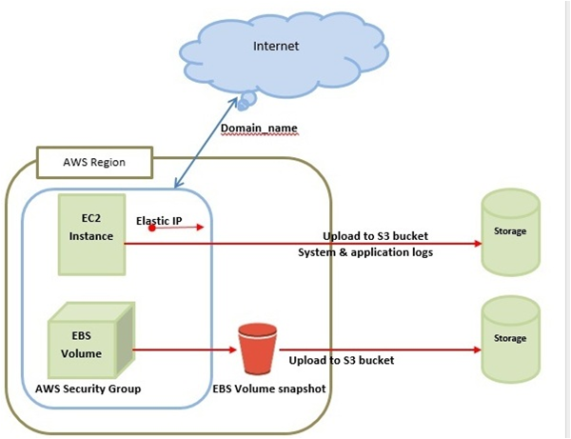

* The above diagram is the basic structure of AWS Architecture where it provides cloud computing services accordingly.
* It is considered as the basic structure of AWS architecture or AWS EC2. Simply, EC2 is also called Elastic Compute cloud which will allow the clients or else the users of using various configurations in their own project or method as per their requirement. There are also different amazing options such as pricing options, individual server mapping, configuration server, etc.
* S3 which is present in the AWS architecture is called Simple Storage Services. By using this S3, users can easily retrieve or else store data through various data types using Application Programming Interface calls. There will be no computing element for the services as well.
* The load balancing component in the AWS architecture helps to enhance the application and the server’s efficiency in the right way. According to the diagrammatic representation of AWS architecture, this Hardware load balancer is mostly used as the common network appliance and helps to perform skills in the architectures of the traditional web applications. It also makes sure to deliver the [Elastic Load Balancing](https://mindmajix.com/aws/creating-an-elastic-load-balancer-in-aws)Service, AWS takes the traffic gets distributed to EC2 instances across the various available sources. Along with this, it also distributes the traffic to dynamic addition and the Amazon EC2 hosts removals from the load-balancing rotation. Elastic load balancing can easily shrink and increase the capacity of load balancing by tuning some of the traffic demands and supporting sticky sessions to have advanced routing services.

Q2. Write steps to create account on AWS. Share Screen shots.

Step-1: Visit the AWS homepage using the following link: <https://aws.amazon.com/>   
Step-2: Click on the “Sign-in to console” option in the top right corner of the screen.  
Step-3: Select “Create a new AWS account” option as shown below.

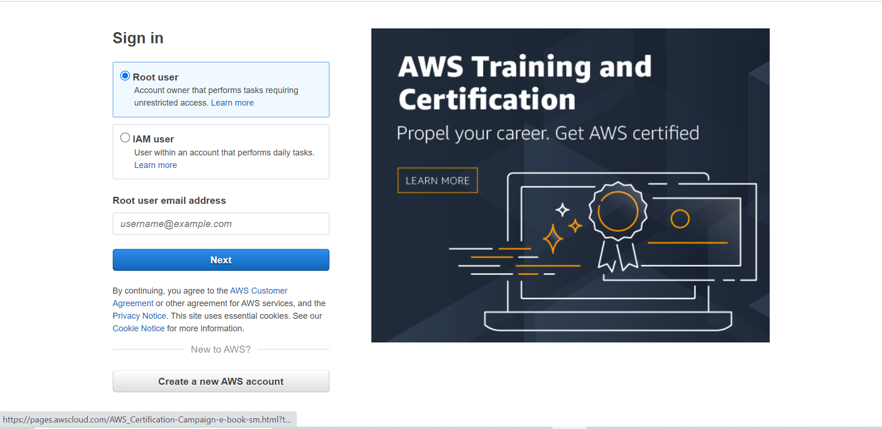

Step-4: Enter the required details (email, username, credit-card details etc), choose the Free-Tier plan and then verify your email address.  
Step-5: You may now sign-in to your account.

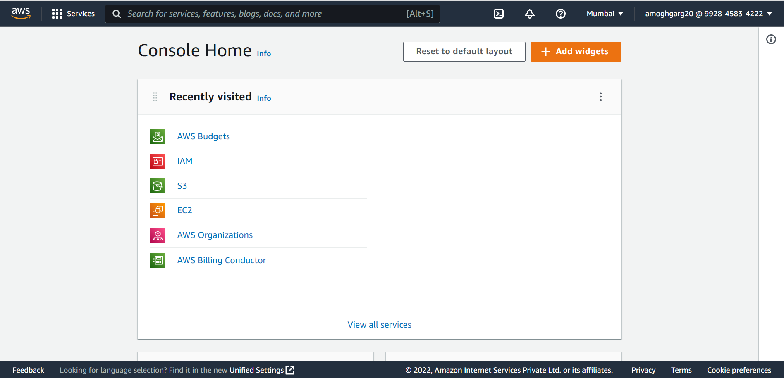

3. (a) What is Amazon EC2 Instance?   
     (b) Create EC2 Instance in AWS. Write steps and share screen.

* EC2 is a machine with an operating system and hardware components of your choice. But the difference is that it is totally virtualized. You can run multiple virtual computers in a single physical hardware. Elastic Compute Cloud (EC2) is one of the integral parts of the [AWS ecosystem](https://intellipaat.com/blog/what-is-amazon-web-services-aws/).
* EC2 enables on-demand, scalable computing capacity in the AWS cloud. Amazon EC2 instances eliminate the up-front investment for hardware, and there is no need to maintain any rented hardware. It enables you to build and run applications faster. You can use EC2 in AWS to launch as many virtual servers as you need. Also, you can scale up or down when there is an increase or decrease in website traffic.
* The word ‘elastic’ in Elastic Compute Cloud talks about the system’s capability of adapting to varying workloads and provisioning or de-provisioning resources according to the demand.

Steps to create an EC2 instance are:

* Step-1: Select EC2 from AWS Services option or you can search from the search bar.

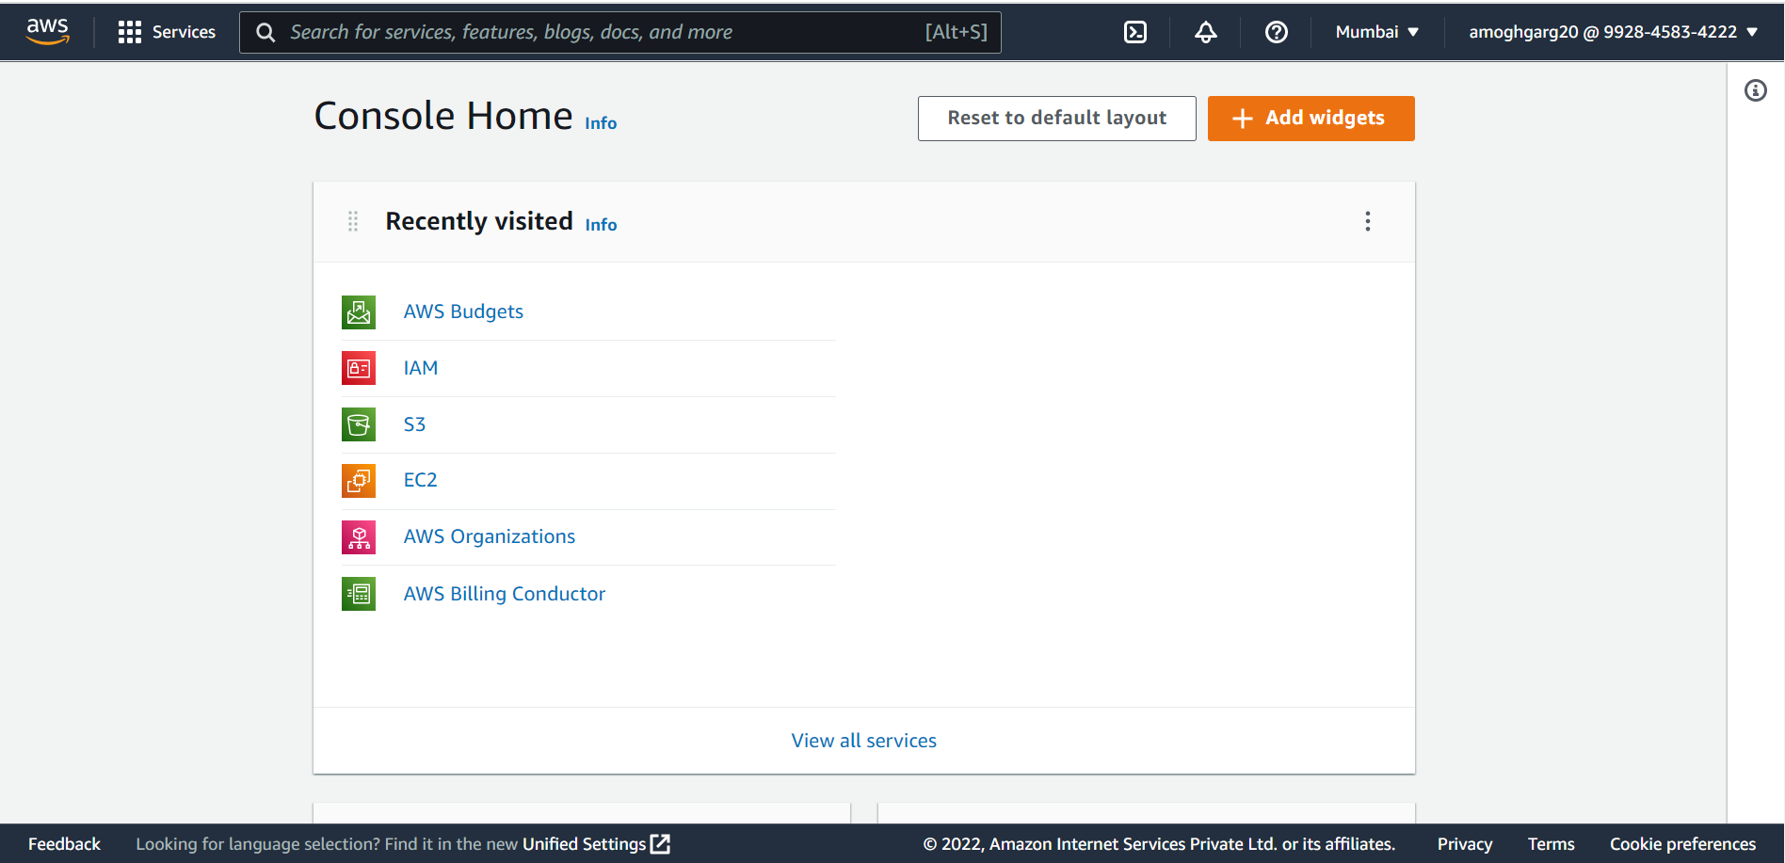

* Scroll up the screen and then select “Launch Instance” option.

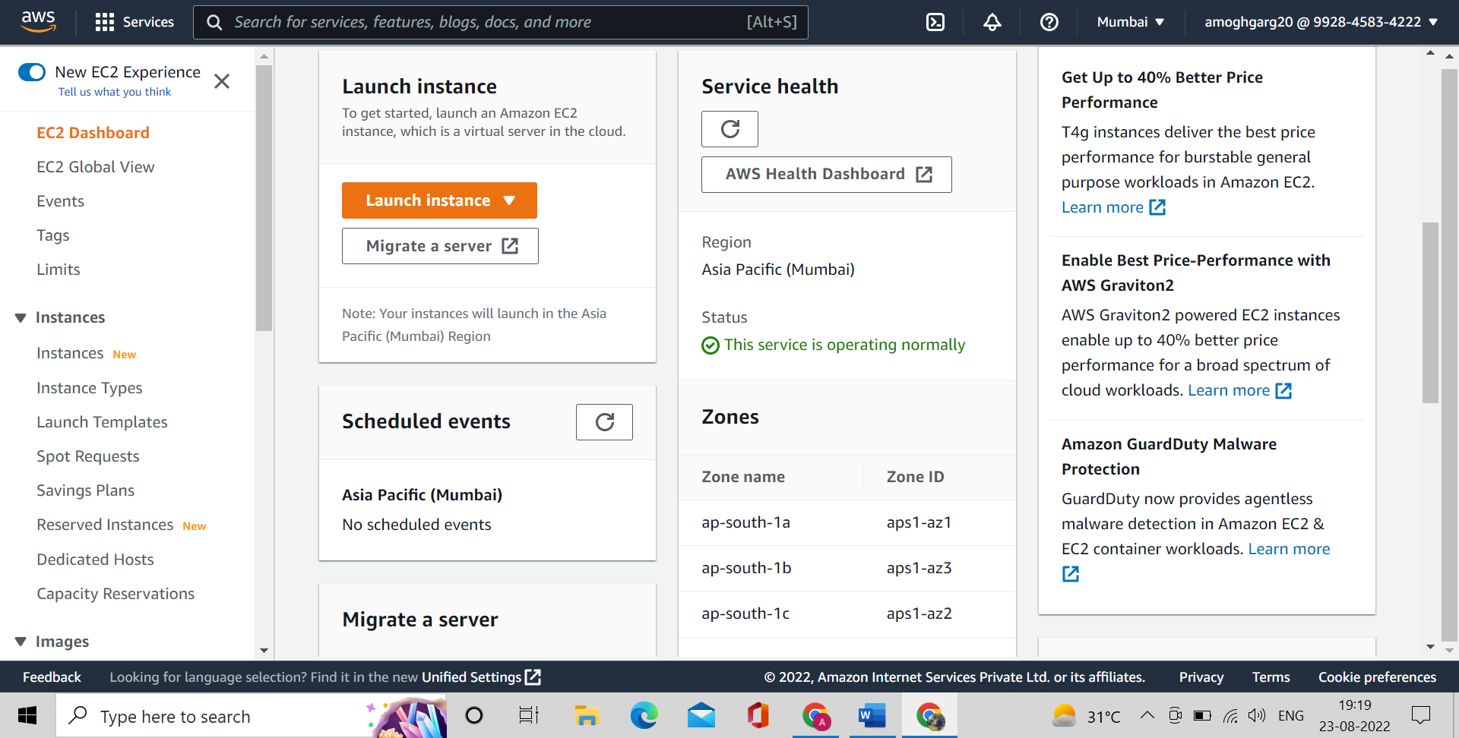

* Enter the name of the instance and then choose AMI type (for example windows). Choose the instance type as “t2.micro”. Let the rest of the details remain as default (or you can change them according to your need).
* Click on “launch instance” option to launch your instance. A success message will be shown on the screen like one shown below.

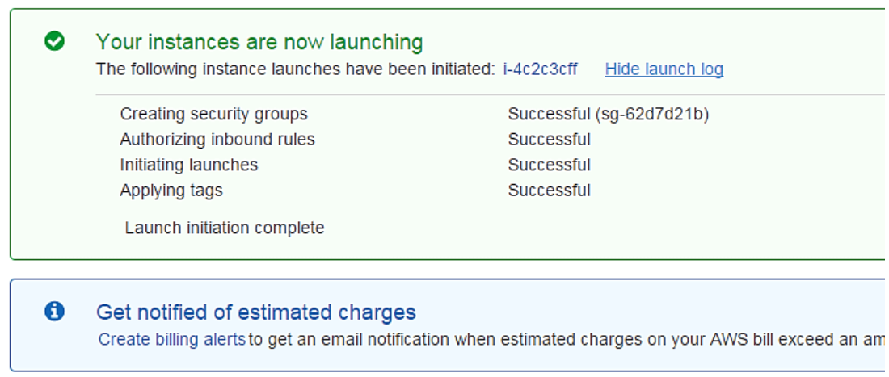

* You can check by going to the EC2 instances whether the instance you created is running or not.

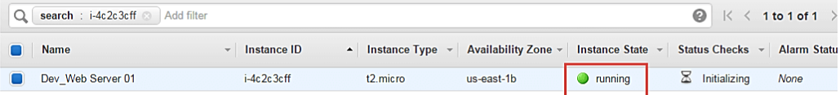

* Instance state “running” means that instance has been launched and is running properly.

**Submitted By: Amogh Garg  
Roll Number: 2020UCO1688  
COE-3**